Ideation Phase
Define the Problem Statements

Date | 29 September 2026
Team ID | SWTID-2026-1757
Project Name | AI StudyBuddy
Maximum Marks | 4 Marks

Customer Problem Statement :
Students often struggle to manage their studies, assignments, projects, exams, and personal activities effectively. They may find it difficult to organize their daily tasks, identify important deadlines, and maintain consistent study habits. StudyBuddy aims to understand these challenges from the students’ point of view and provide a simple, personalized solution that helps them plan their studies, track progress, manage time, and stay motivated to achieve their academic goals.

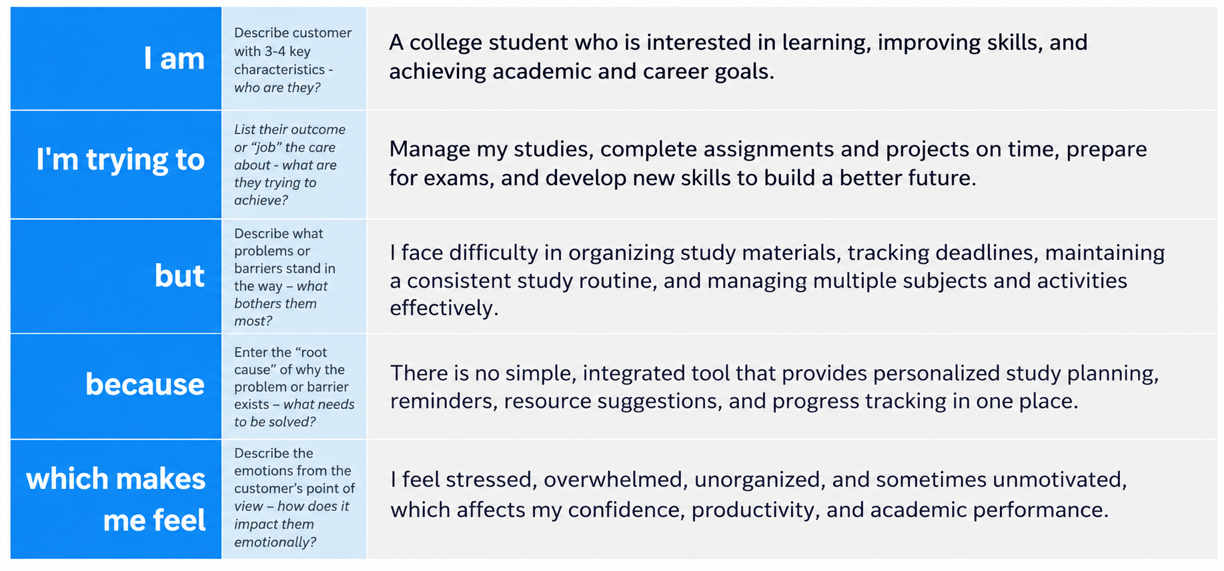
Example:
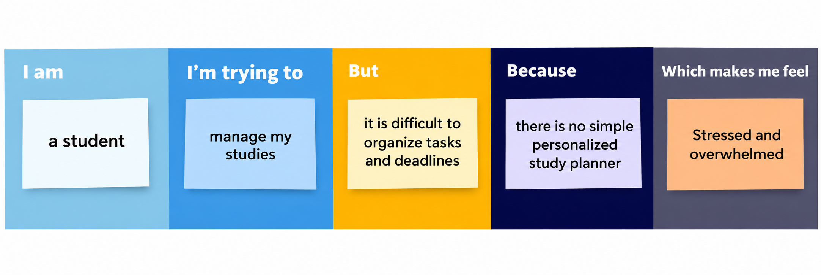
Problem Statement (PS) | I am (Customer) | I’m trying to | But | Because | Which makes me feel
PS-1 | A college student | Manage my studies and daily tasks | I find it difficult to organize assignments and deadlines | I don’t have a simple study planning system | Stressed and overwhelmed
PS-2 | A student preparing for exams | Complete my syllabus on time | I struggle to maintain a consistent study routine | I lack proper reminders and progress tracking | Worried and unmotivated

